**NAME : AWANTIKA KHATRI**

**STUDENT ID : BIT-24S-015**

**DEPARTMENT : INFORMATION TECHNOLOGY**

**SUBJECT : ARTIFICIAL TECHNOLOGY**

**LAB:4**

**TASK:1**

**Write a Python program to take two numbers as input and perform all arithmetic operations on them.**

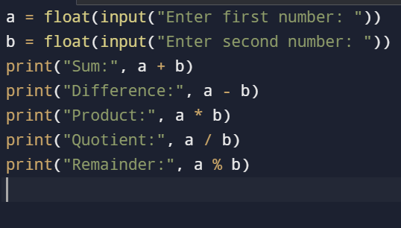

**OUTPUT**

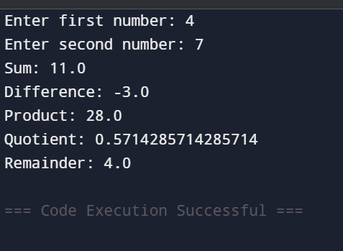

**TASK:2**

**Create a function that takes two numbers and returns their sum, difference, product, and quotient.**

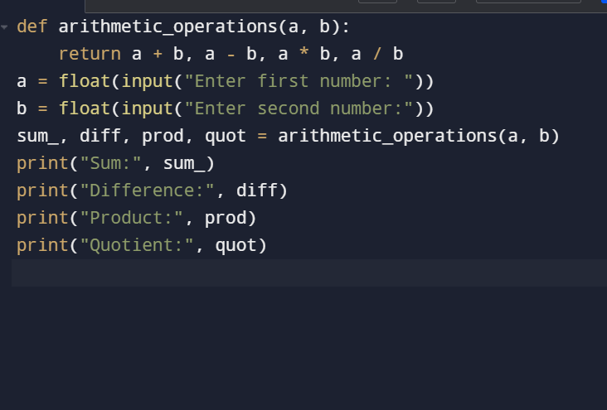

**OUTPUT**

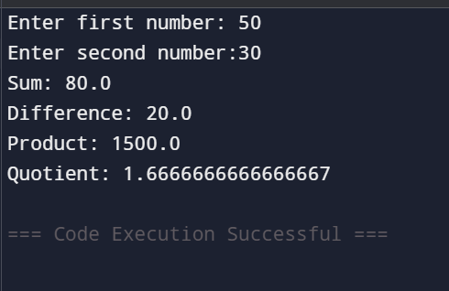

**TASK:3**

**Write a Python script to find the remainder when one number is divided by another.**

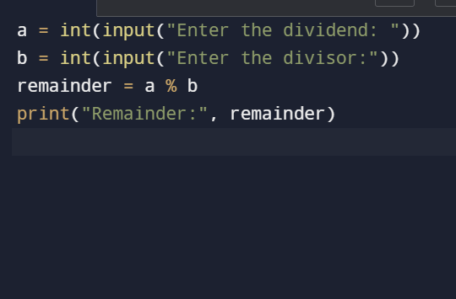

**OUTPUT**

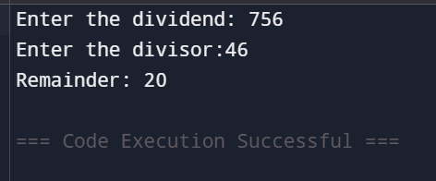

**TASK:4**

**Write a program to calculate the area of a circle using the formula: Area = π * r^2.**

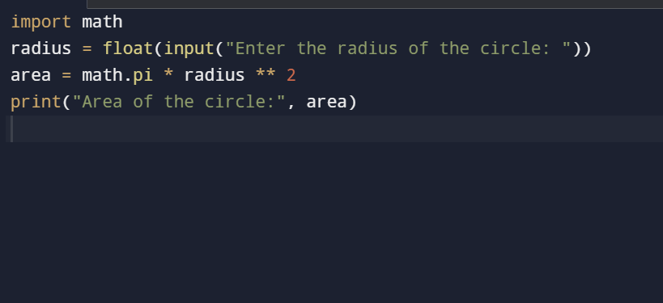

**OUTPUT**

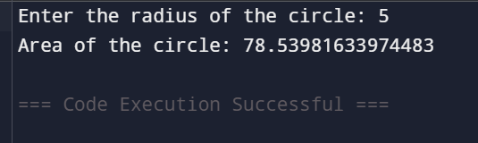

**TASK:5**

**Implement a program that takes a number as input and returns its square and cube using exponentiation.**

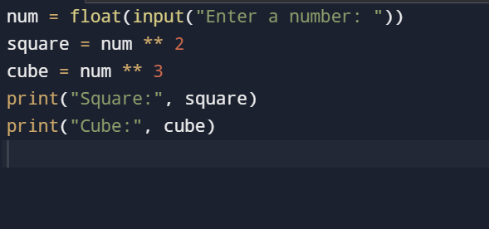

**OUTPUT**

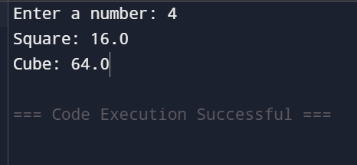

**TASK:6**

**Create a simple calculator in Python that allows the user to choose an operation (addition, subtraction, etc.) and inputs two numbers.**

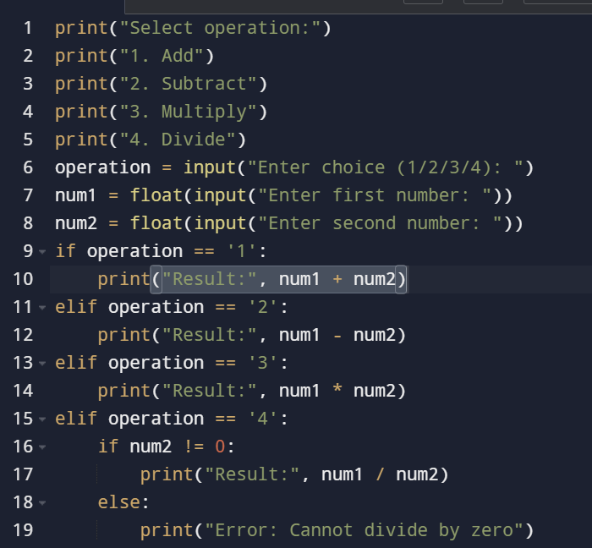

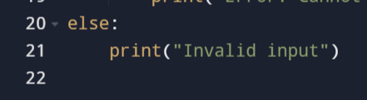

**OUTPUT**

**ll**